**Slowloris attack (kind of dos attack)**

Step 1: Open your Kali Linux and then Open your Terminal.

Step 2: Create a new Directory on Desktop named Slowloris using the following command. mkdir Slowloris

Step 3: Move to the directory that you have to create (Slowloris). cd Slowloris

Step 4: Now you have to clone the Slowloris tool from Github so that you can install it on your Kali Linux machine. For that, you only have to type the following URL in your terminal within the Slowloris directory that you have created. git clone https://github.com/gkbrk/slowloris.git

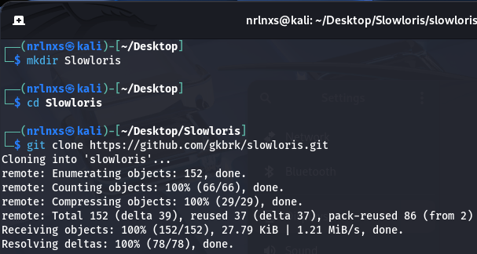

You have successfully installed the Slowloris tool in your Kali Linux. Now it's time to perform a denial of service using the following steps.

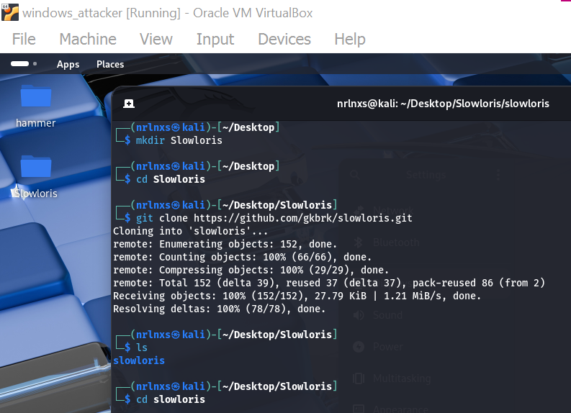

Step 5: We can see that our server is under active status it means is running properly, now come back to the first terminal, and to check permissions run the following command. ls -l

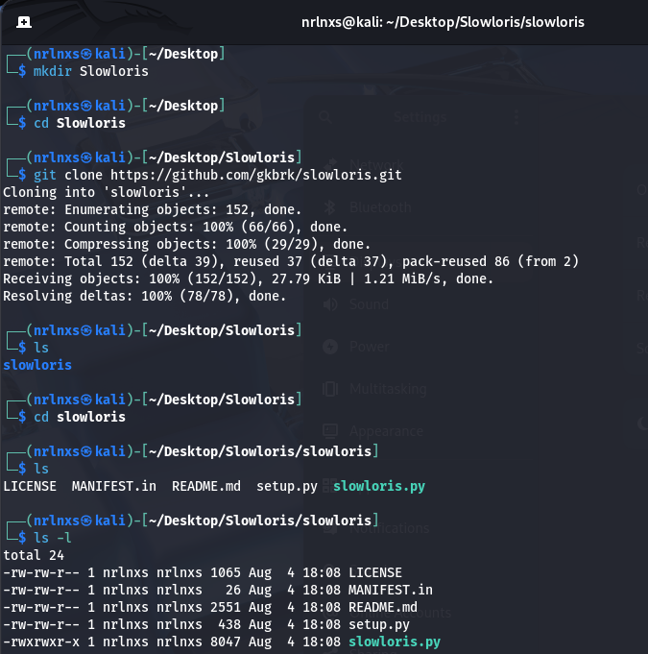

Step 6: open another terminal.

Step 7: Now you have to check the IP address of your machine to do that type of following command. ifconfig

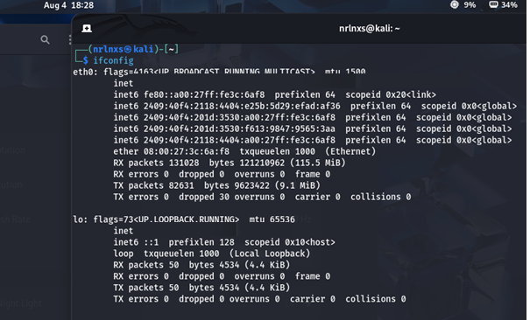

Step 8: As you can see we got our IP address now it's time to start the apache server, start the apache server using the following command. sudo service apache2 start

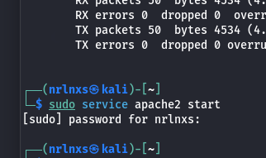

Step 9: Now we have to check the status of your server whether it is active or not so to check the status of your server run the following command. service apache2 status

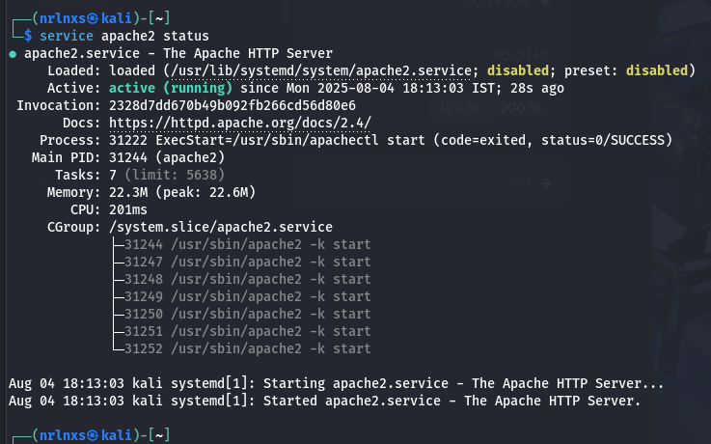

Step 10: Now it's time to run the tool using the following command. python3 slowloris.py (your ip address) -s 500

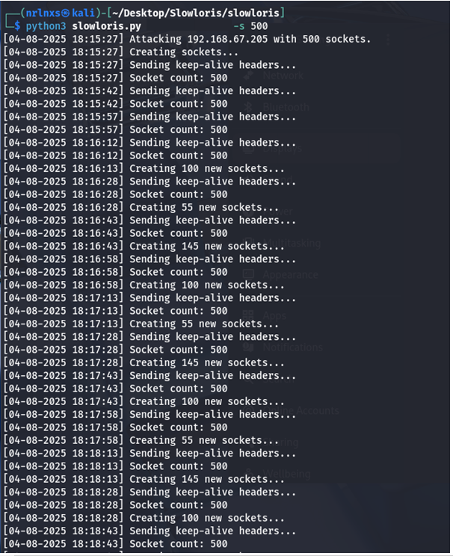

Step 11:Check Apache Server Load / Threads

Run this on your Kali attacker or target server:

ps aux | grep apache2

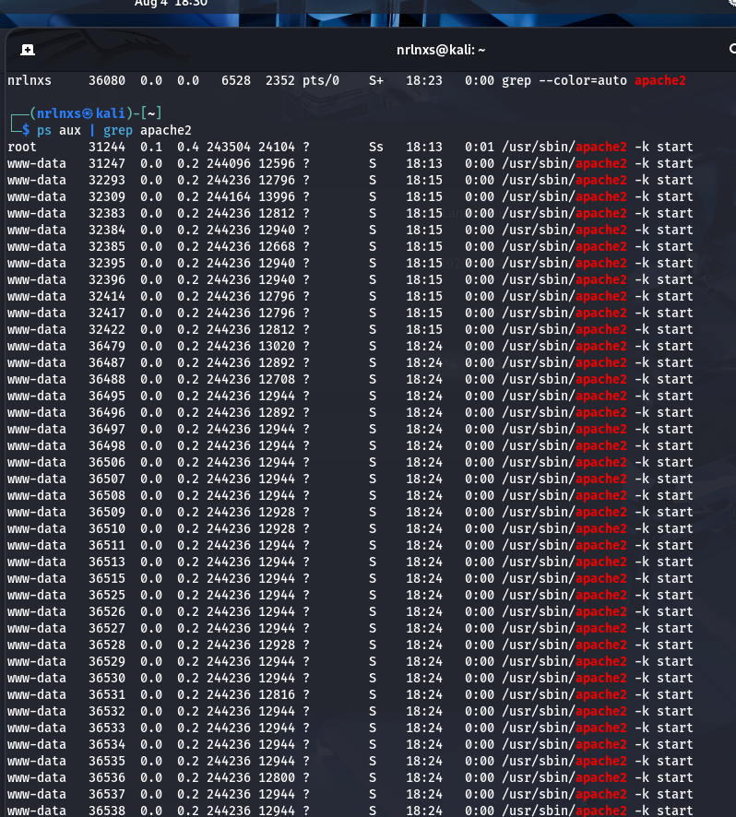

You'll notice many Apache worker processes handling partial connections.

The number of processes will increase under attack.

Step 12: You can see the tool has started attacking that particular IP address which we have given now to check whether its working or not go to your browser and on your URL bar type that IP address, and you will see the site is only loading and loading take long time to opening this is how Slowloris tool works.



Step 13: Stop the attack using ctrl+c

